**1. INTRODUCTION**

Handwritings are the most common standard and regular medium that human beings use in communicating. It is also an effective and efficient way to record information even with the introduction of new technologies, like SwiftKey keyboard, sound command, etc. Generally, handwriting recognition system is a mechanism that used to recognize human handwritten in any languages either from scanned handwritten image or real time handwriting using stylus pen on electronic device which also can be called as offline and online handwriting respectively [1]. Besides, the application of this system can be categorized into three which are numeral, character and cursive word. It is widely used in numerous applications such as language translation, bank cheques and keyword spotting [2, 3].

Figure 1. A Typical Handwritten Recognition System

As shown in Figure 1, the common processes of handwriting recognition system are image acquisition, preprocessing, segmentation, feature extraction and classification [2]. Image acquisition is the first step to get an image form of handwritten that will act as input to preprocessing by using scanner. The preprocessing step is to remove noise or distortions of the scanned image which usable for further process [3, 4]. One of the processes in preprocessing is thresholding which convert scanned image into binary image. Next, segmentation is used to divide each word into sub-images where this stage is very important step particularly for continuous handwriting in order to extract features from each image of character which will be perform in feature extraction process [1]. Then proceeds with feature extraction where it will extract every characteristic of the features in each image. This feature is very useful for classification in the last step. There are many classification techniques such as K-Nearest Neighbour (KNN), Neural Network and Support Vector Machine (SVM) where these classifiers have different approach to recognize the image [4]. Generally, most researcher evaluate the performance of the system based on classification accuracy [5, 6]. Although many paper has been conducted on offline handwritten recognition, but the use of Deep Neural Network (DNN) is still in the early stage. Therefore, the objective of this paper is to develop offline handwritten recognition using DNN. We will use two popular databases, including MNIST [7] and EMNIST [8] due to the clean data provided. Thus, the algorithms that will be used in this project start with feature extraction where we will use image pixel as feature input to classifier [9] as DNN will handle both feature extraction and classifier. Finally, we will evaluate the performance of this proposed project based on confusion matrix to find the classification accuracy.

**2. DESIGN OF PROPOSED HANDWRITTEN RECOGNITION SYSTEM**

Figure 2 shows the proposed handwritten recognition system. The processing step includes image thresholding, character thinning using morphological operation, slant correction, and finally image segmentation. The pixel value from image segmentation will be treated as the incoming input to the DNN, in which both feature extraction and classification will be conducted.

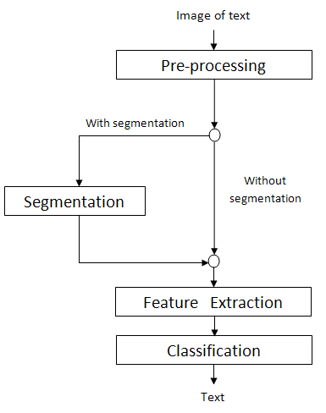

Figure 2. Proposed Handwritten Recognition System